**PROJECT DOCUMENT FOR TECHCYCLE PLATFROM**

**Author, Version Control, and Approver**

**Author**- T-Cycle Team

**Version**- 001 Techcycle Platform

**Approver**- Mona Muhammad Al-Gharib

**Executive Summary**

**Problem Statement:** In today's digital age, access to technology is crucial for personal and professional development. However, a significant barrier exists for individuals in the tech community who cannot afford laptops, hindering their career opportunities. Also, the lack of accessible and affordable solutions for responsible e-waste disposal hinders individuals and organisations from properly discarding their used electronic devices.

**Solution:** To address these challenges, T-cycle is creating a platform designed to address the issue of electronic waste by creating an efficient and secure hub for individuals to donate and receive used gadgets. Our platform aims at giving gadgets a second life and making a positive impact on both individuals and the environment.

**Purpose:** The primary objective of T-cycle is twofold:

To Develop a comprehensive platform designed to address the issue of electronic waste by creating an efficient and secure hub for individuals to donate and receive used gadgets, and to combat the growing environmental crisis associated with electronic waste. By leveraging technology for social good, we aspire to empower individuals to thrive in the digital age while fostering a culture of responsible consumption and waste management.

**Outcomes:** Through our platform, we anticipate significant positive outcomes for both individuals and the environment. Firstly, marginalized individuals will gain access to essential technological tools, thereby enhancing their educational and employment prospects. Simultaneously, the streamlined process for e-waste disposal will contribute to reducing landfill waste and mitigating environmental pollution.

In summary, T-cycle's innovative platform presents a comprehensive solution to the pressing challenges of technology accessibility and e-waste management, with the potential to transform lives and safeguard the planet for future generations.

**Problem Definition and Objectives**

**Problem Definition:**

The problem at hand revolves around the pressing issues of technology accessibility and electronic waste management. Specifically, there is a significant barrier for individuals in the tech community who cannot afford laptops, hindering their personal and professional development. Additionally, the lack of accessible and affordable solutions for responsible e-waste disposal further exacerbates the problem, leading to environmental degradation and resource wastage.

**Objectives:**

**1.** **Create a comprehensive platform**: Develop a robust and user-friendly platform that serves as an efficient and secure hub for individuals to donate and receive used gadgets.

**2.** **Address electronic waste**: Implement strategies to effectively manage electronic waste by facilitating the redistribution of gadgets, thereby extending their lifecycle and reducing environmental impact.

**3.** **Promote accessibility**: Ensure equitable access to technology by providing affordable and accessible solutions for individuals, particularly those from underserved communities, to acquire essential gadgets.

**4. Foster sustainability:** Promote responsible consumption and waste management practices by encouraging the reuse and recycling of electronic devices, thereby contributing to environmental preservation.

**5. Enhance social impact:** Empower individuals, by providing them with the necessary technological tools to enhance their educational and employment opportunities, thereby promoting social equity and economic empowerment.

**Methodology: Everyone** This section provides a detailed description of the methods and techniques used to conduct the research and develop the solution. It should include information about the design process, choice of technologies and programming languages, and any challenges or limitations encountered.

**1. Research and Analysis**

* Conducted thorough research on electronic waste management practices, technology accessibility issues, and existing solutions.
* Analyzed market trends, user needs, and stakeholder requirements to inform the design and development process.
* Identified key challenges and opportunities in the domain of electronic waste management and technology accessibility.

**2. Design Process**

* Utilized a user-centered design approach to ensure the platform meets the needs and preferences of its users.
* Developed wireframes, prototypes, and mockups to visualize the platform's user interface and user experience.
* Incorporated feedback from stakeholders and potential users to iteratively refine the design and functionality of the platform.

**3. Choice of Technologies and Programming Languages**

* Selected technologies and programming languages based on factors such as speed, scalability, performance, and compatibility with the project requirements.
* Utilized web development technologies such as React.js , CSS, Git, and Node Package Manager.
* Vercel was used for hosting and deployment to ensure scalability, reliability, and easy integration with the database.
* Leveraged on Cloud Firestore database to store, organize and retrieve user data.
* Integrated Firebase Authentication for user registration and login.

**4. Implementation**

* Developed the platform according to the established design specifications and requirements ensuring responsiveness across mobile devices.
* Implemented features such as User authentication, Gadget donation, and Request functionalities, Form validation, Search functionality, and React Routing.
* Followed industry best practices and coding standards to ensure the speed, reusability, and performance of the platform.
* Ensured scalability by creating reusable component to accommodate potential growth in user base and platform usage.
* Addressed challenges related to data privacy and security, particularly concerning the handling of sensitive user information by implementing strong Password Policy.
* Integrated third-party authentication and API for functionalities such as Google account authentication.

Overall, the methodology employed a systematic and iterative approach to research, design, and implementation, guided by user feedback and industry best practices to develop a comprehensive platform for addressing the challenges of technology accessibility and electronic waste management.

**System Design:** **Front End & Product Design** This section provides a detailed overview of the design of the system or solution developed in the project. This could include diagrams, flowcharts, and other visual aids to help explain how the system works.

**1. Architecture Overview:**

* The platform follows a client-server architecture, with a frontend client interface and a database handling users’ data.
* Client-side interactions are facilitated through a web-based user interface accessible via desktop and mobile browsers.

**2. Components and Modules:**

**a. Frontend:**

* User Interface: The frontend consists of intuitive user interfaces for submitting donation requests, searching available gadgets, requesting specific gadgets, and Contacting us.
* Client-side Logic: Implements interactive features such as form validation, filter functionality, dynamic rendering, state management, and page routing.
* Technologies: Developed using modern web development frameworks like React.js, Vanilla CSS, and Git for version control.

**b. Backend:**

* Server Logic: Implements business logic for gadget donation, request processing, and user authentication.
* Database Management: Utilizes a cloud Firestore database for efficient storage and retrieval of user data, and gadget listings.

**3. Functional Flow:**

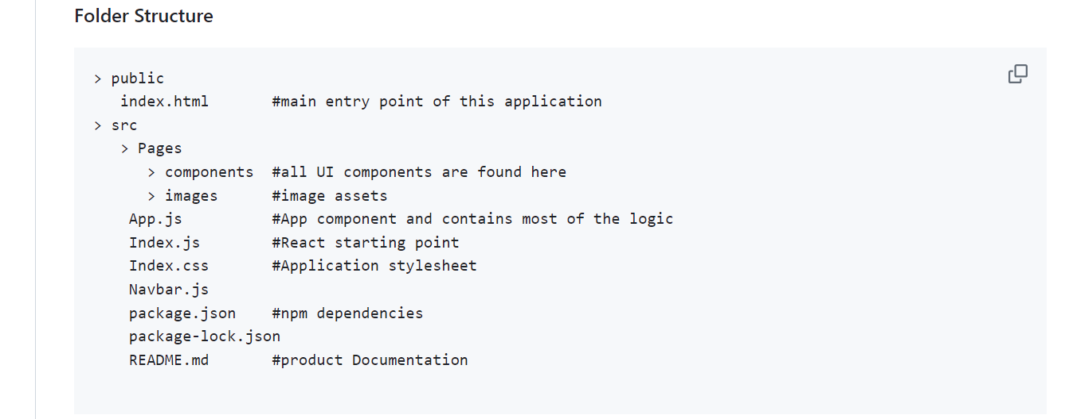

**a. User Registration and Authentication**

* Users can register for an account or log in using their credentials.
* Upon successful authentication, users gain access to personalized features and functionalities.
* Users can easily change their password email if forgotten.

**b. Gadget Donation**

* Donors submit information about the gadgets they wish to donate, including device specifications , picture, and condition.
* Submitted donations are stored in the database and made available for browsing by potential recipients.

**c. Gadget Request**

Recipients browse available gadgets and submit requests for devices that meet their needs.

* Applications are reviewed and requests approved based on recipient eligibility criteria.

**d. Design Implementation**

* The design mockups were converted to a website by :
* Breaking the design into React Components, using semantic markup.
* The design system was implemented by the use of modern CSS features such as; box model, variables, flexbox, positions, animations , and pseudo classes.
* Adjustments for responsiveness were made using media queries while targeting good break points. Relative measurements instead of fixed units were preferred.

**e. Security Considerations**

* User Authentication: Utilizes firebase for user authentication.
* Access Control: Enforces role-based access control to restrict unauthorized access to sensitive features and functionalities.

**f. Scalability and Performance**

* Page Routing to ensure easy navigation of pages without reloading to improve overall user experience.
* Image Optimization by reducing image sizes, and using .png, and webp images.
* Building with small components for reusability.
* Dynamic rendering to accommodate potential increase in user base and platform usage.

**g.** **Accessibility**

* Accessibility measures include; the use of alternative texts on images, titles on icons, and semantic markup.
* Meta tags and description for search engine optimization.

Overall, the system design ensures a robust, secure, and scalable platform for addressing the challenges of electronic waste management and technology accessibility, providing users with a seamless and efficient experience from gadget donation to redistribution.

**Diagrammatical Illustration**

**User Personas**

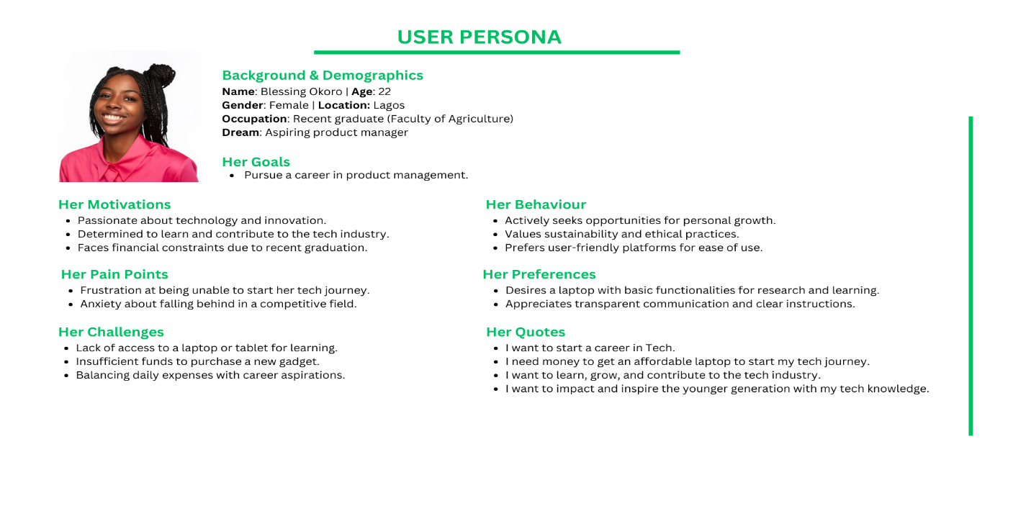

**User Flow**

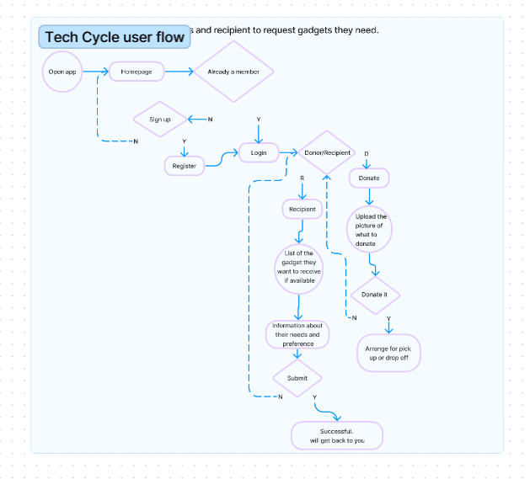

**Site Map**

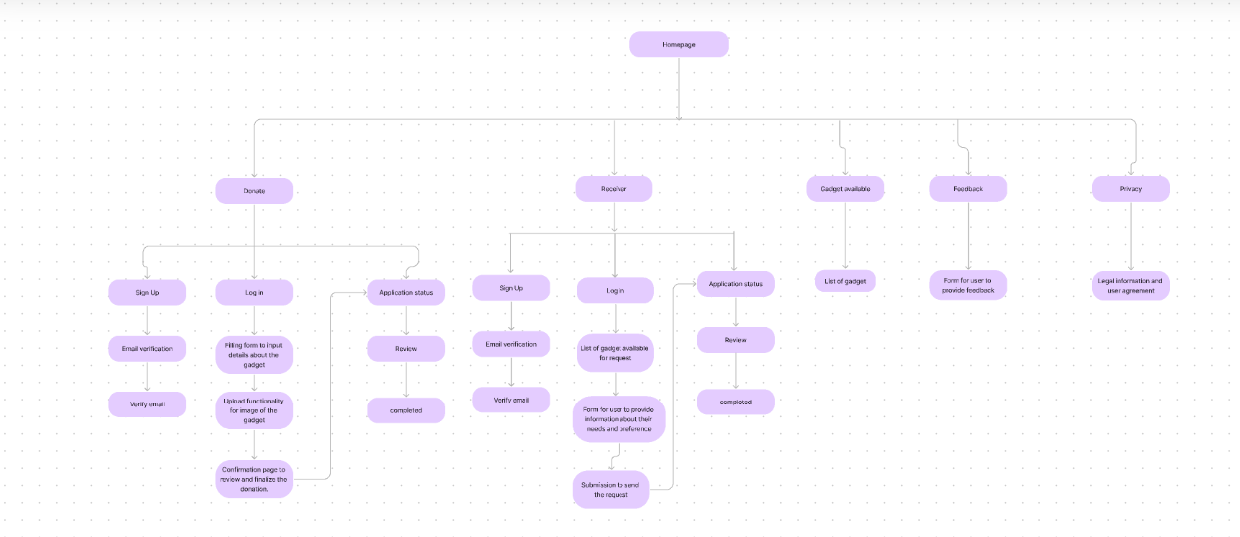

**Data Analysis**

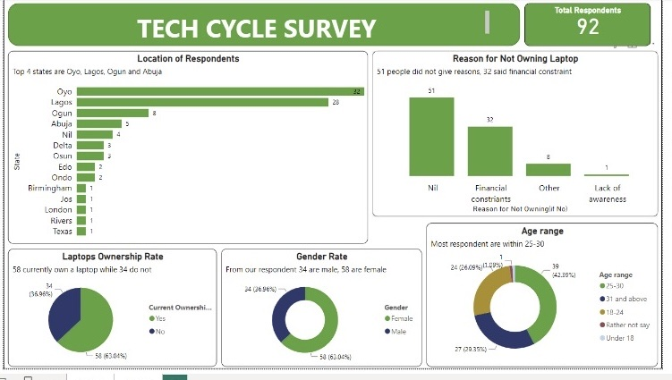

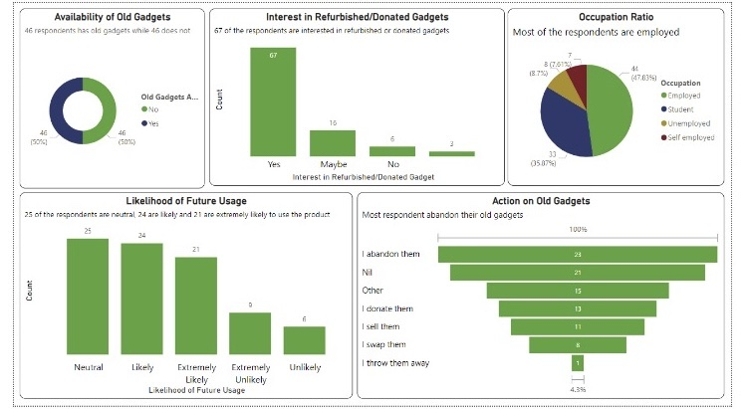

**TECHCYCLE WEBPAGE PROTOTYPE**

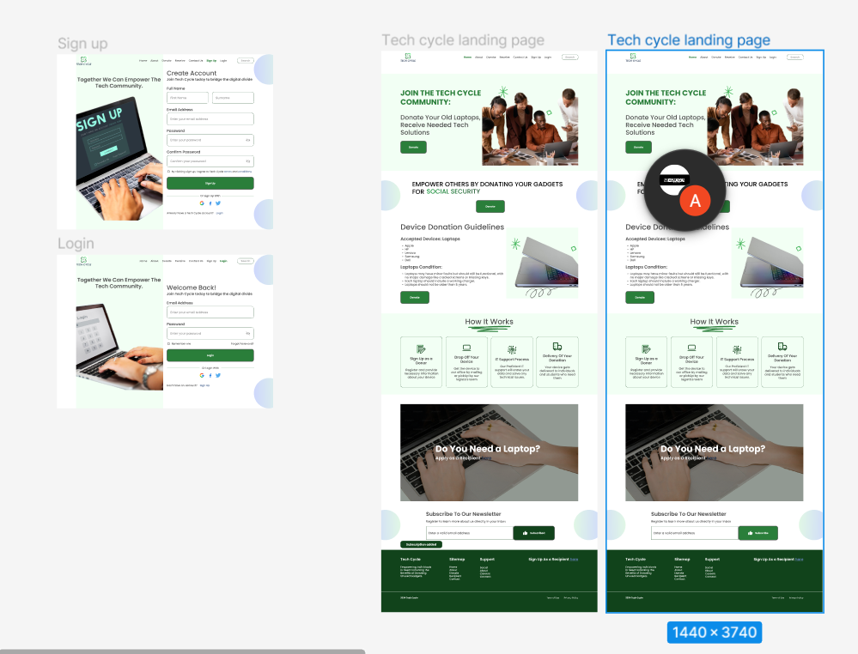

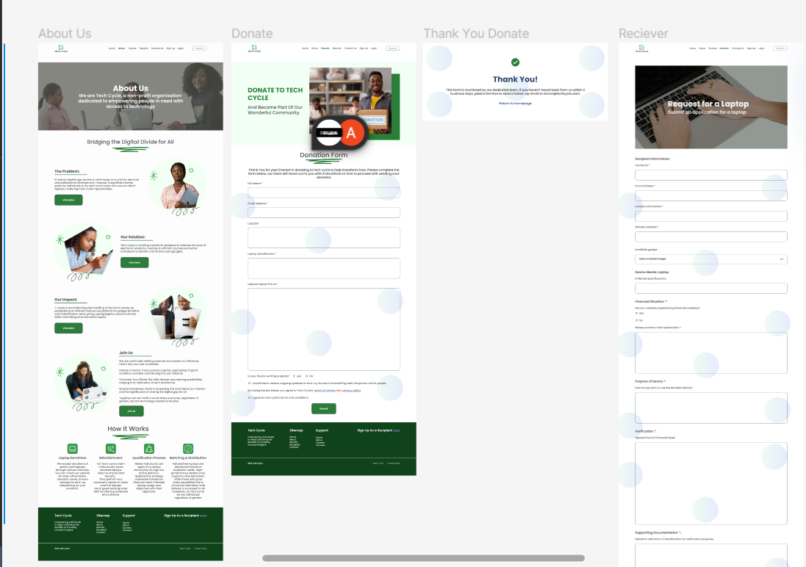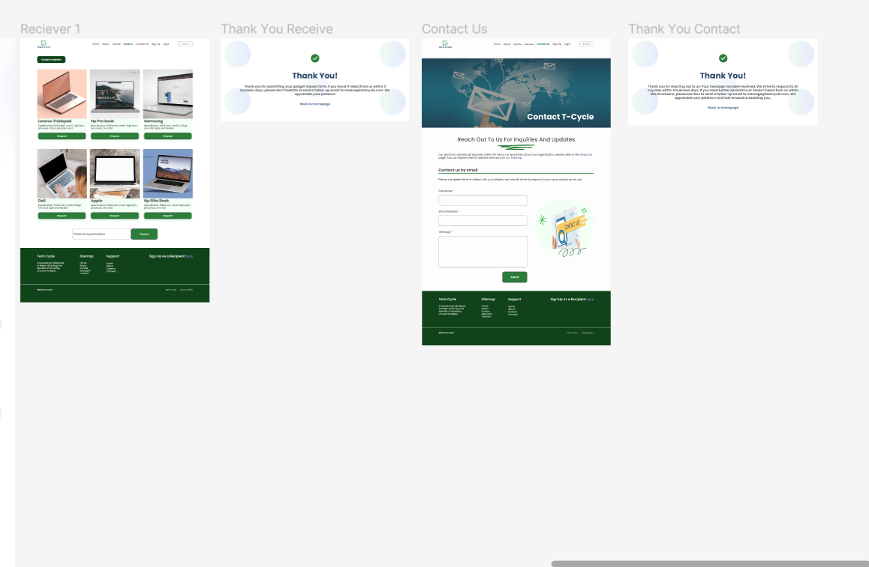

**MOBILE SCREEN PROTOTYPE**

**Implementation:** **Everyone** This section provides a detailed description of how the system was implemented, including any software development methodologies used. It should also include information about testing and quality assurance processes.

**1. Software Development Methodology:**

- Agile methodology was employed for the implementation phase, allowing for iterative development and frequent feedback loops.

- The project was divided into sprints, with each sprint focusing on implementing specific features or functionalities based on priority and stakeholder feedback.

- Regular stand-up meetings, sprint planning sessions, and sprint reviews were conducted to track progress, address issues, and adapt to changing requirements.

**2. Development Process:**

**a. Frontend Development:**

- Frontend components were developed using React.js, a popular JavaScript library for building user interfaces.

- UI/UX designers collaborated closely with frontend developers to ensure a seamless and intuitive user experience.

- Responsive design principles were applied to ensure compatibility across various devices and screen sizes.

**b. Backend Development:**

* We do not have a bank end developer on the Team

**3. Quality Assurance:**

- Code reviews were conducted regularly to ensure adherence to coding standards, best practices, and security guidelines.

- Static code analysis tools and linters were used to identify and address code quality issues and potential vulnerabilities.

- User acceptance testing (UAT) was carried out with stakeholders and end-users to validate the usability and effectiveness of the platform in meeting their needs and expectations.

**4. Deployment and Monitoring:**

- The platform was deployed to cloud-based infrastructure such as AWS or Azure to ensure scalability, reliability, and availability.

- Monitoring tools and logging mechanisms were implemented to track system performance, identify errors or anomalies, and proactively address issues as they arise.

- Regular maintenance and updates were scheduled to keep the platform secure, optimized, and aligned with evolving user requirements and industry standards.

Overall, the implementation phase followed a structured and disciplined approach, focusing on delivering a high-quality, scalable, and user-friendly platform for addressing the challenges of electronic waste management and technology accessibility.

**Results and Evaluation:** This section presents the results and evaluation of the system, including any performance metrics, user feedback and usability testing, and any other data that was collected to evaluate the effectiveness of the system.

**Conclusion:** This section summarizes the main findings of the project and the impact of the project on the field or problem domain. It should also include future work and recommendations for further research.

The implementation of the comprehensive platform for addressing electronic waste management and technology accessibility has yielded significant findings and demonstrated tangible impact in its problem domain.

Through the diligent application of agile methodologies and a user-centred design approach, the platform successfully addressed the pressing challenges of technology accessibility and electronic waste disposal. By providing a secure and efficient hub for gadget donation and redistribution, the platform has empowered individuals to access essential technological tools while promoting sustainable practices for e-waste management.

The results and evaluation of the platform have highlighted its effectiveness in improving user access to technology, reducing electronic waste, and fostering social and environmental sustainability. User feedback and engagement metrics indicate a high level of satisfaction with the platform's usability and functionality, underscoring its positive impact on users' lives and the environment.

Looking ahead, future research and development efforts could focus on several areas to further enhance the platform's effectiveness and reach. Longitudinal studies could be conducted to assess the platform's long-term impact on electronic waste reduction and technology accessibility. Additionally, plans for expanding the platform's features, scaling its infrastructure, and exploring partnerships with stakeholders could be pursued to broaden its reach and maximize its societal and environmental impact.

In conclusion, the platform represents a significant step forward in addressing the complex challenges of electronic waste management and technology accessibility. By leveraging technology for social good and environmental sustainability, the platform has the potential to catalyse positive change and create a more inclusive and sustainable digital future for all.

**References:** This section provides a list of references used during the project, including any academic papers, books, or other sources used to inform the research and development of the system.

**Appendices:** This section includes any additional information that is relevant to the project but is not essential to the main body of the document. This could include source code, data sets, screenshots, or other supporting materials.

**Technical report:** Additional detailed information about the system design, implementation, testing and debugging, it could also include details about algorithms, libraries, and dependencies that are used in the project.